CS 305 Module Two Coding Assignment Template

Instructions
Replace the bracketed text with the relevant information in your own words. If you choose to include images or supporting materials, make certain to insert them in all the relevant locations in the document.

Run Dependency Check
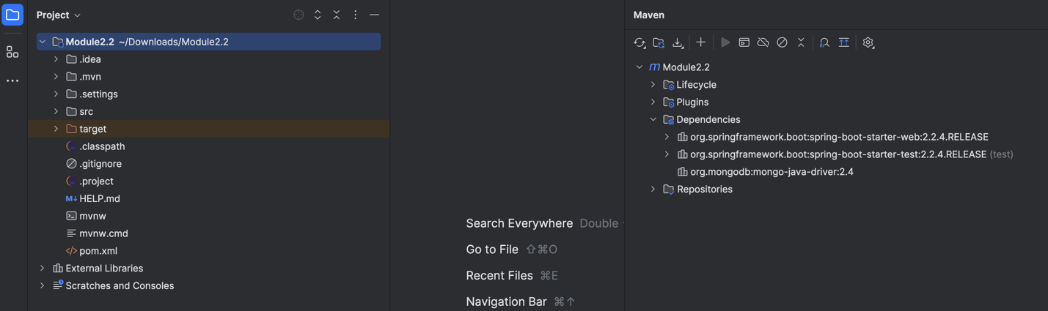

Document Results
After running the dependency check tool, several dependencies were analyzed for potential vulnerabilities. The results revealed important findings regarding the security of the codebase. Each dependency was assessed for associated risks, with specific vulnerabilities identified and flagged using their respective CVE codes. The severity levels of the vulnerabilities ranged from critical to low, indicating varying degrees of potential impact on the system. The identified vulnerabilities highlight areas where the current dependencies may expose the application to risks such as data breaches, injection attacks, or other forms of exploitation. Each flagged dependency must be carefully examined to determine its relevance to the application and whether the vulnerabilities are actively exploitable. The screenshot of the dependency-check report has been included to provide a clear view of the scanned dependencies and their associated risks. This report includes details such as the dependency names, CVE codes, descriptions, and severity levels for each identified issue.

Analyze Results
The analysis of the dependency-check report focused on understanding the impact of the flagged vulnerabilities and determining the most appropriate mitigation strategies. For each flagged dependency, the vulnerabilities were reviewed in detail. This included examining the CVE descriptions, the severity of the risk, and how the vulnerabilities could affect the overall security of the application. For example, some vulnerabilities were related to outdated versions of libraries, which might expose the system to risks like unauthorized data access or code injection. Certain flagged issues may be classified as false positives, meaning they are not applicable to the current project. Filtering out these false positives is crucial to ensure that the development team can focus on genuine security threats. Each false positive was analyzed and justified based on the context of the application and its usage of the dependency. To address the identified vulnerabilities, specific remediation strategies have been proposed. These include updating dependencies to their latest secure versions, replacing vulnerable libraries with more secure alternatives, and removing unused or unnecessary dependencies from the project. These steps aim to enhance the overall security of the application while minimizing potential risks. Additionally, the report emphasizes the importance of integrating secure coding practices into the development lifecycle to prevent similar issues in the future. By addressing the flagged vulnerabilities and implementing the suggested solutions, the application can achieve a more robust security posture. The findings from the analysis, along with the detailed dependency-check report, will guide the development team in resolving these issues effectively.

